**DATA ANALYSIS WITH COGNOS**

**PROJECT TILE:** COVID-19 VACCINE CASES.

**Project Definition:**

The aim of the project is to collect and analyse data in detail on vaccinated people and fully vaccinated by year and country.

The main objective of the project is to analyse the data on, COVID-19 vaccinations. Through the analysis of data, we can find out some important insights.

**Design thinking:**

Data collection:

The data are collected from official page WHO and some health organizations, government databases, and research publications.

The global sample of 23,000 respondents included 1,000 participants from each of 23 countries surveyed (Brazil, Canada, China, Ecuador, France, Germany, Ghana, India, Italy, Kenya, Mexico, Nigeria, Peru, Poland, Russia, Singapore, South Africa, South Korea, Spain, Sweden, Turkey, the United Kingdom and the United States) ([Methods](https://www.nature.com/articles/s41591-022-02185-4#Sec4)). Half of respondents (50.3%) were women, and one-fifth of respondents (22.2%) had a university degree. Age groups (18–29; 30–39; 40–49; 50–59; and 60+) were approximately equally represented (16.8–22.9%). Nearly half of all respondents reported income above their country’s median (45.6%). Healthcare workers (HCWs) represented one in ten (10.8%) of all respondents

Data Preprocessing **:**

In data cleaning I cleaned the data with the transform data option present in Power BI because the dataset was not cleaned and included some missing values, so with the help of the duplicates function in Power BI, I cleaned the data and replace the null values with 0 and then started working on it.

Analysis:

In observation found some interesting points that are mentioned below.  
• According to data on people fully vaccinated in the year.  
• The dataset available is from 2020 to 2021  
• Total vaccination by the country in map visualization.  
• Total Highest Daily vaccination is 9223133948 in 2021.  
• Total Highest vaccination is 704952663700 in China.  
• Highest number of vaccinations by the source name is the Ministry of Health is 7.41K.  
• Top 10 countries with fully vaccinated:  
• Top 10 Daily vaccination in the countries:  
  
Top 10 countries with the top 10 vaccine

Top 10 Countries where most people are vaccinated.

Insights and Recommendations:

• In conclusion, we can take a look at the final Report for further analysis.  
• We can see the top 10 sources.  
• Countries by fully vaccination etc. • We can collect good datasets for analysis.  
• We can analyze the data of the overall world.  
• Like this dataset we can perform operations with various categories, city-wise or region-wise.  
• We can work on large datasets and analyze them with the proper format of the chart.

Visualization:

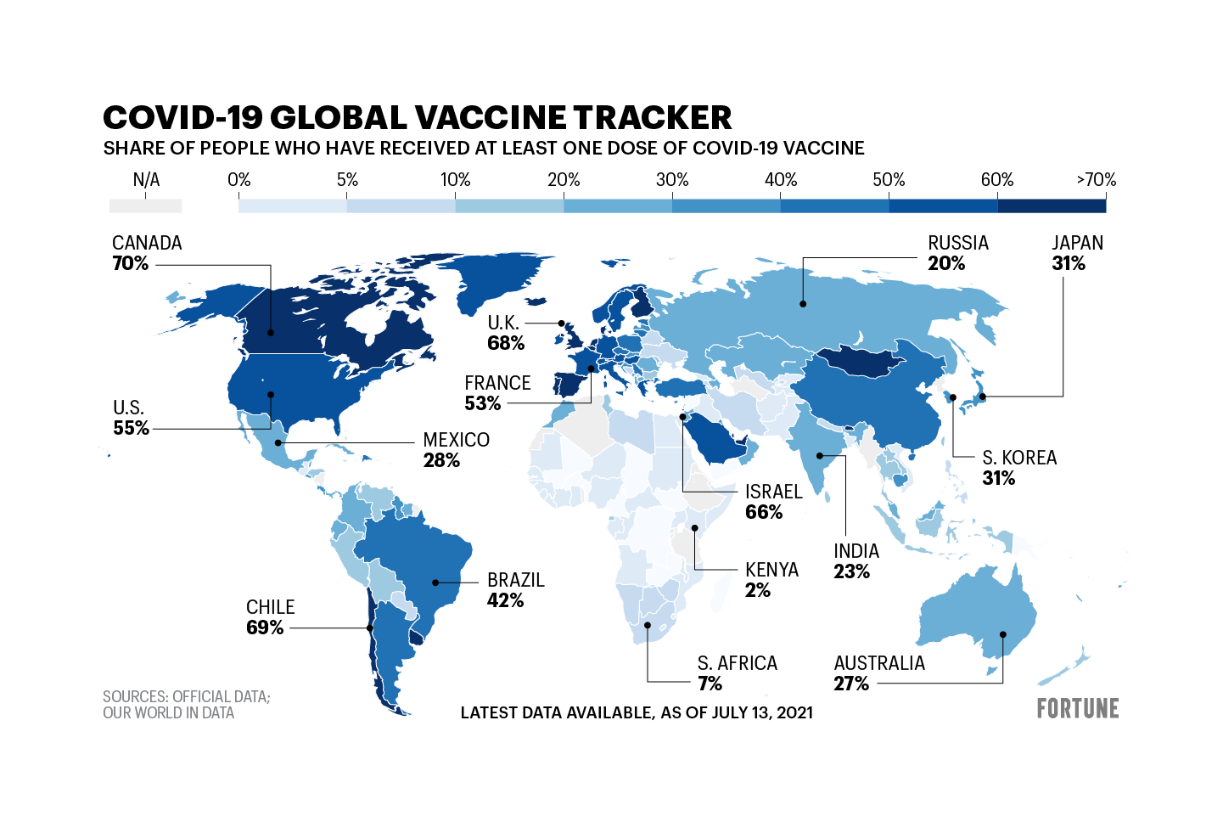

Visualization of covid vaccine cases